NORTH CAROLINS WING STAFF VACANCY ANNOUNCEMENT

Assistant Director of Personnel

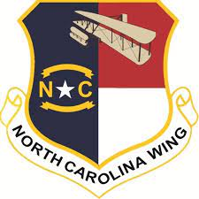
Assistant Director of Personnel
DUTIES AND RESPONSIBILITIES (Ref: CAPP 30-1):
Manages and administers the CAP personnel program and associated administrative procedures to include:
• Membership records and applications
• Confidential screening (FBI fingerprint cards)
• Organizational actions (charters, deactivations, etc.)
• Appointments 35 CAPP 30-1
• Promotions and demotions
• Awards and decorations
• Duty assignments
• Transfers
• Retirements
• Membership terminations/Adverse Actions
• Uniforms

POSITION REQUIREMENTS
- Experienced CAP officer an understanding of CAP structure and operations at the unit, group, wing. (Required)
- At least a Technician Rating in the Personnel Specialty Track (Preferred)
- Previously served as a Squadron or Group Personnel (Desired)

- Completed Level II of the CAP Education and Training Program (Required)

ASSIGNMENT REQUIREMENTS:
- Unit Assignment – Will be an additional duty assignment
- Position reports to: Director of Personnel

SELECTION AND APPLICATION PROCESS:
- Submit via email a letter of intent with a resume of relevant experience to Lt Col Christopher Duemmel at christopher.duemmel@ncwgcap.org Please copy Maj Jordan Crawford at Jordan.crawford@ncwgcap.org

DUE DATE:
15 January 2023

